Gender Analysis Iraq (rCARI pilot)
Background
At WFP, food security data is typically collected and analyzed at the household level; the following program design and assistance are also provided to the household as a unit. Meanwhile, there could be a discrepancy in food security levels between different household members (intrahousehold food security). It is in this context that the WFP Food Security Needs Assessments and Targeting (RAM-N) teamed up with the Gender Equality Office (GEN) to study the intrahousehold differences in food security. The aim was to collect the evidence necessary to guide WFP operations at the assessment, planning and implementation phases to address intrahousehold variability in food security.
This study set out to answer the following questions:
- Is minimum dietary diversity (MDD) different for men and women of the same household?
- Is dual data collection from more than one individual within a household needed to provide evidence on intrahousehold discrepancy in dietary diversity?
- Are the reduced coping strategies index (rCSI) results for the same household influenced by the sex of the respondent?
- Are the responses to the newly developed gender-sensitive rCSI module influenced by the sex of the respondents?

In Iraq, this gender study was conducted using some of the available and newly developed individual level food security indicators. Through this study, 590 households were sampled from 2 IDP and 2 refugee camps. As the sample was limited (less than 1000 households), two interviews could be conducted (one with a male and one with a female member of the same household). The respondent of the opposite sex was usually the spouse or the household member with the smallest age difference from the primary respondent. These two individuals were then asked about their dietary diversity, coping strategies and gender empowerment questions.

Results
- Is minimum dietary diversity different for men and women of the same household?












In Iraq, taking a paired sample of 303 households (where it was possible to have both a male and female respondent from the same household), the average MDD of women was 4.8, while the average MDD for men was 4.7. It also suggests that there are no significant differences in MDD by sex. However, if we look more closely at the paired consumption of the different food groups, some significant differences can be observed – with women consuming more dark leafy green vegetables and vitamin-A rich vegetables and fruits such as pumpkins (Figure 1).
0.99
0.98
0.45
0.44
0.47
0.47
0.0
0.02
0.22
0.22
0.84
0.84
0.52
0.48
0.21
0.17
0.55
0.54
0.18
0.20

Figure 1. Percentage of individuals (from same household) reporting on consuming different food items the day before the survey
In addition, looking at the paired MDD by households’ food consumption groups (FCG) (where the same for the acceptable food consumption score or FCS, n=270; and poor/borderline FCS, n=33), we see that women typically scored slightly better for MDD in households in the acceptable food consumption group; however, in the poor/borderline FCG, men scored slightly better. Looking further at the consumption of the different food groups for households in the poor and borderline FCG (using the paired sample), we also see differences across the board between women and men respondents, but those for pulses and other vegetables are significantly different – with men consuming more in both cases. The indicative results of the differences in consumption of pulses were particularly stark for men, where 80% of men had consumed pulses the day prior compared to 23% of women in households with poor FCS.
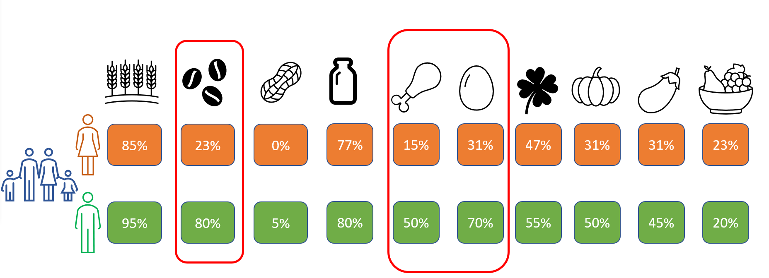
Figure 2. Percentage of individuals (from same household) reporting on consuming different food items the day before the survey
The data show that when households are food secure, the dietary diversity of households are equal, with women eating slightly more vitamin A-rich foods. However, when households are vulnerable and consuming poorer diets, men tended to prioritize eating certain food groups (pulses, meat, and eggs).
Similarly, taking the unpaired sample – meaning the total number of primary respondents to the questionnaire by female and male respondents (n=431, 193HH with male primary respondents and 238 HH with female respondents), the overall averages for MDD appear similar, with an average of 5.1 for women and 5.2 for men. However, if we break down the responses by FCG, or households with acceptable FCS (n=381) and households with poor/borderline FCS (n=50), we see differences in responses by the sex of the respondents, especially within the poor/borderline FCG. Overall, males scored higher on dietary diversity in the poor/borderline category than female respondents (5.3 for males, compared to 4.1 for females), but females within the acceptable category again scored better than males (5.4 vs. 5.0).
Further, differences between women and men’s consumption of some food groups were observed within the unpaired sample, with women eating more dark leafy greens compared to men (57% vs. 44%) and other vegetables (71% vs. 55%, respectively). Additionally, when broken down by FCG, within the poor/borderline category, looking at the gendered responses, we also observed differences between consumption of pulses (52% for women vs. 94% for men), meat (15% for women and 48% for men) and eggs (33% for women and 65% for men). Thus, based on the indicative results of the paired and unpaired samples, this could mean that when households are doing ok, then women tend to eat better than the men; however, within households that are worse off or eating a poorer diet, then men in the household still tend to eat better.
The data show that using dual data collection method (asking two respondents – one male and one female - from the household) and analyzing the individual level indicators by the sex of the primary respondents revealed the same results.

- Are the results of the reduced coping strategies index influenced by the sex of the respondent?

The results of the paired analysis by sex of the rCSI showed that there were no differences between average rCSI reported by female or male respondents of the same household 13.30 women, 13.34 men (Figure 3). Results were the same also for each of the 5 questions composing the rCSI module.
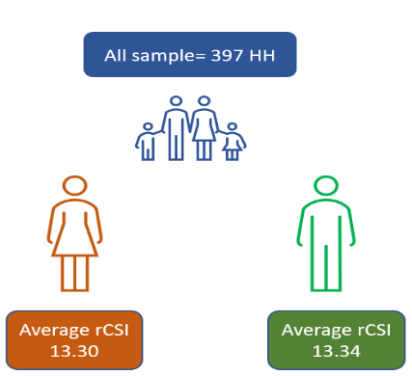
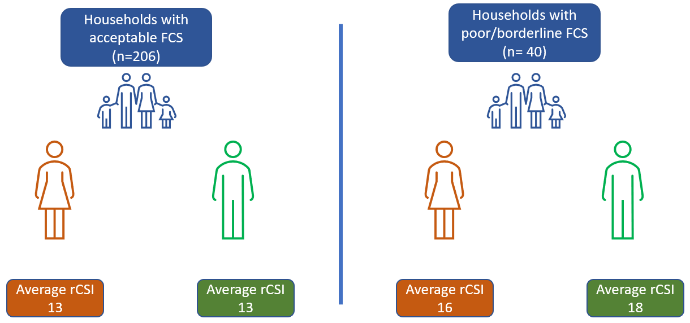
Looking a bit deeper at households with different vulnerability statuses, in households that are worse off (with insufficient food consumption), males from the same household tended to report that the household is applying more negative coping strategies than females (18 average score for males, vs 16 average score for females). The results are indicative but not statistically significant due to the small sample size of the households with insufficient consumption (40 households). Looking at the individual questions, men in these households with poorer consumption tended to report more often: borrowing food, reducing portion sizes, restriction of consumption of adults for children and reducing the number of meals per day.
Figure 3. Overall average reduced coping strategies index (from individuals in the same household).
Figure 4. Average reduced coping strategies index (from individuals in the same household), split by food consumption group (acceptable vs. poor/borderline)
In general, the gender of the respondent within the household does not influence the responses to rCSI questions, however, among vulnerable households, males tend to report slightly higher coping strategy applied for the entire household.
- Are the responses to the gender-sensitive rCSI questions influenced by the sex of the respondent?
When respondents were asked which of the household members applied the coping strategies mentioned (male, females, or both equally), the results from the paired analysis showed that the sex of the respondent in the household influenced the response to this question. Both male and female respondents tended to report that between mainly adult males or females that they (the male or female respondent) applied the strategies concerned.
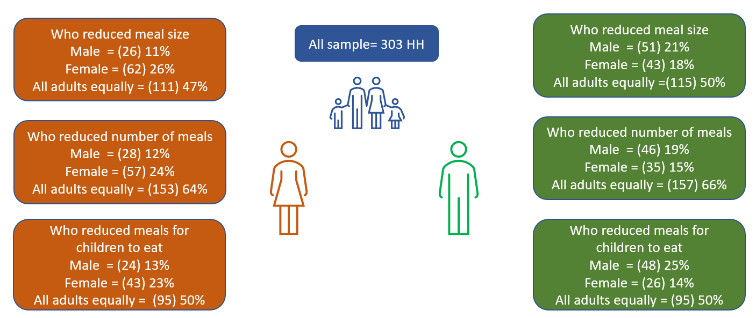
Figure 5. Percentage of respondents (from same household) reporting which household member (a male household member, female or all adults equally applied each of these (3 of 5) coping strategies in the rCSI.
Further, data from remote data collection (mVAM) in Angola, Somalia, Zimbabwe, and Malawi showed the same results – using unpaired samples.
Data shows that the collection of data on the gender sensitive rCSI questions is influenced by the respondents’ sex. Therefore, the collection of this indicator the perspective of the respondent, and it is biased towards the respondents’ sex; it does not reflect reality.
Limitations
There are several technical and practical limitations of conducting household assessments at the individual level.
The first limitation is related to the design of the assessment:
- A limited number of indicators are available at the individual level, including Minimum Dietary Diversity of Adults (normally MDD-W for women, but in this case both males and females were interviewed) and the individual dietary diversity score (IDDS).
- In household assessments, the sampling frame cannot be obtained at the individual level. If the household is selected, then an extra step of sampling individuals needs to take place.
There were also practical challenges related to individual-level (intrahousehold) data collection:
- Which member of the household is the best representative to speak on behalf of the household?
- If more than one individual is interviewed (e.g., head of the household and spouse), then how many are enough (e.g., 2)?
- If both sexes (male and female) need to be interviewed, this requires double the enumerators (thus double cost) and time for data collection; and,
- If both are not available at the same time, this also requires multiple visits (increasing interview time, and costs).
Therefore, the data collection for this pilot was done on a small sample of households. For a nationally representative assessment, the sample would have to be much larger, especially when looking at the data disaggregated by food consumption groups (FCG).

Conclusions
In general, there was no discrepancy detected between male and female respondents on individual dietary diversity within the same household. For vulnerable households, which do not have sufficient food consumption, there might be slight differences in individual diversity of consumption between men and women of the same household; however, this is only indicative. Thus, the collection of intrahousehold data, involving data collection of more than one household member, does not add much information compared to the analysis of individual dietary diversity by the sex of the respondent. However, more testing of the individual level dietary diversity is needed using unpaired samples through other pilots.

In addition, it was determined that the responses to the gender-sensitive rCSI questions are extremely variable depending on the sex of the respondents; therefore, it is not a reliable measure for determining who (whether primarily men/fathers or women/mothers) applied the coping strategies in order to make any programmatic decisions. At the household level, there were no differences in the responses between male and female respondents of the same household. Thus, there is no need to further pursue the gendered responses to the rCSI questions.

In general, the collection of this additional information – gendered responses to questions, especially at the individual (intrahousehold) level - could potentially guide WFP programming and assistance; however, there must be a justification for the extra resources invested in the data collection exercises..

MDD is a dichotomous indicator (asking yes/no) of whether adults consumed 10 food groups the day prior to the survey (i.e., yesterday), and is intended to capture adequate consumption of various nutrients and vitamins. While usually minimum dietary diversity (MDD) is asked only of women, this study set out to analyze individual dietary diversity by the sex of respondents. (For more info: Minimum Dietary Diversity for Women (MDD-W) - Data Analysis - WFP VAM Resource Centre)
rCSI is an indicator used to compare the hardship faced by households due to shortage of food. The index measures the frequency and severity of the food consumption behaviors the households had to engage in due to food shortage in the 7 days prior to the survey (For more info: reduced Coping Strategies Index - Data Analysis - WFP VAM Resource Centre)
Gender-sensitive rCSI questions were developed specifically with the gender team, and set out to determine, within the past 7 days, who in the household applied the following strategies: (1) limited the portion size, (2) restricted consumption so that children could eat, or (3) reduced the number of meals eaten per day; the response options included: mainly adult male(s) or female(s), male or female children/youth, all adults equally, and all family members equally.

